A full risk assessment MUST be completed every time the site conditions change.
In the event that the works do not meet the criteria of the risk assessment, the works MUST cease and contact needs to be made with the Supervisor.

Office Use ONLY

Address:
Road Speed:
Traffic Management:
Is Road Traffic Sensitive? | YES / NO Traffic Sensitive Times:
Works Reference Number:

 | YES | NO
Has environmental screening been completed?
Have the repair crew been briefed on all permit conditions and any extra requirements for the work? (e.g. manual control of lights between *am and *pm)
Is all of the relevant paperwork attached to this risk assessment for the repair crew? (e.g. utility plans, permit conditions, copy of permit, work instructions, method statement etc.)
Are the plans that have been provided adequate and clear?
Has this site already been attended previously? If YES, is there anything learnt from the previous visit that needs to be briefed to the new repair crew?

Name: Signature:

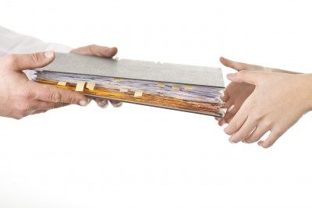

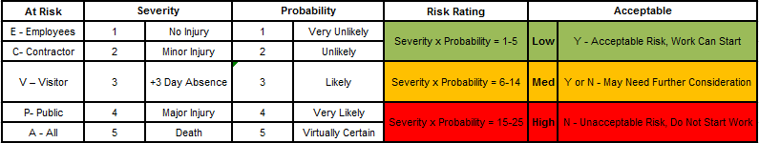
On Site Risk Assessment

 | YES | NO
Competency & PPE
Are you trained, competent and authorised to do this work?
Is your method statement available and understood?
Do you have all of the correct PPE required to do this work safely? (Hard hat, safety boots, protective overalls, protective goggles, ear defenders, dust masks, reflective vests)
If YES is your PPE suitable and in good condition?
Environment
Are the works being completed out of hours?
Are there any environmental issues (noise pollution, vegetation, tree roots, wildlife etc.)?
If you have answered YES to either of the above - have Environmental Health been contacted?
Are the weather conditions acceptable for the works to continue?
Is there enough light and space to start work?
Site Set-Up
Do you have the right amount of signing, lighting and guarding to set up this site safely?
Is your signing, lighting and guarding in good condition?
Is the intended traffic control suitable?
Are the road widths wide enough for the intended traffic management?
Do approaching road users have enough visibility of the works?
Are the works near any railway or level crossings?
Will the works restrict the access to premises? Has the customer been consulted?
Are there any businesses/schools/emergency services/bus stops/care homes etc. nearby? Do they have enough access to their premises?
Are the works close to a junction?
Are the works close to a bend/hill/roundabout?
Are there any overhead cables?
Is the minimum width able to be maintained on the footway?
What are the options for pedestrians?
Has wheelchair, pushchair and mobility scooter access been considered?
Will someone come along the road or footway and understand exactly what is happening and what is expected of them?
Are the repair crew able to maintain safe access to and from site?
Does your site meet the safety requirements of the Safety at Street Works and Road Works Code of Practice (Red Book)?
Excavation
Has a CAT & Genny been used to establish other underground apparatus?
Is your CAT & Genny calibrated?
Do you have the right tools and equipment to carry out the dig?
Is the excavation over 1.2m deep, is trench support required?
Are there any extra provisions that need to be made to make this excavation safe?
Are there any live conductors or cables exposed?
Is there any risk of back feed or local generation?
Manual Handling
Is any lifting required?
If YES has the asset load, route etc. been considered?
Materials
Is your plant stored in a suitable and safe area?
Do you have fuel on site?
If YES do you have drip trays/spill kits? Is the fuel in the correct containers?
Are there clear means of raising an alarm if a potential hazard arises? (e.g. gas leak)
Confined Space
Is the access by a stairway?
Is being able to exit in an emergency safe and relatively quick?
Are there unknown oxygen levels in the atmosphere?
Unattended Sites
Do any of the signs or barriers need lamps?
Do the signs and barriers need to be weighted?
Is all of the plant and material stored in a safe place?
Are footway or carriageway boards required over an open excavation?
Did contact need to be made with your site supervisor? If so, why and what was the outcome?

Other Comments:

THIS IS YOUR RISK ASSESSMENT WITH YOUR SIGNATURE
Name: Signature:

